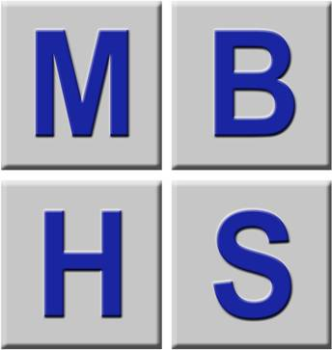 | DSE Workstation Checklist

This checklist can be used as an aid to risk assessment and to help compliance with the Schedule to the Health and Safety (Display Screen Equipment) Regulations. | 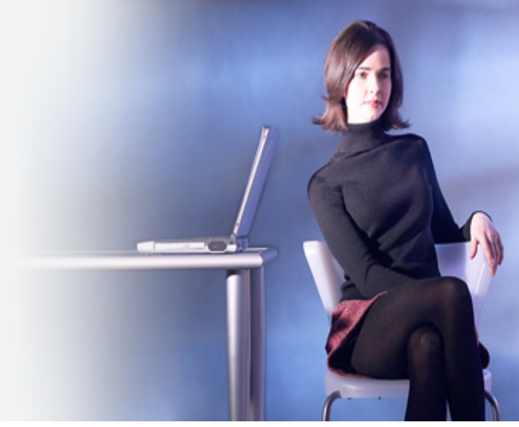
How to use it
Work through the self assessment checklist, ticking either the ‘yes’ or ‘no’ column against each item:
- ‘Yes’ answers require no further action;
- ‘No’ answers require investigation and may need remedial action. You can record your suggestions for this in the ‘Action to Take’ column;
- Workstation assessors should check later that agreed actions have resolved the problem.  Remember the checklist only covers the workstation and work environment. You also need to find out if risks from other aspects of the work are being avoided. For example, has the employer given VDU users health and safety training, and provided for breaks or changes of activity in their work?  What action should be taken  Working through the checklist will identify problems and should also help to suggest action to reduce risks. |  | Company Name:  1  Workstation location:  Name:  Assessment checked by:  Date of assessment:  Any further action needed?  YES/NO  Follow-up action completed on:

Areas to be investigated when making an assessment | Tick answer  YES NO |  | Ways of reducing the risk |  | Action to take

1. Display screens

Are the characters clear and readable?  Health  & safety  Health  & safety | ✓   |  | Make sure the screen is clean and cleaning materials are made available.  Check that text and background colours work well together.

Is the text size comfortable to read? |  |  | Software settings may need adjusting to change text size.

Is the screen image stable, i.e. free of flicker and jitter? |  |  | Try using different screen colours to reduce flicker, e.g. darker background and lighter text.  If problems still exist, get the set-up checked, e.g. by the equipment supplier or IT Dept

Is the screen’s size specification suitable for its intended use? |  |  | For example, intensive graphic work or work requiring fine attention to small details may require a larger display screens.

Are the brightness and/or contrast adjustable? |  |  | Separate adjustment controls are not essential, providing the user can read the screen easily at all times.

Does the screen swivel and tilt?  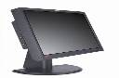 |  |  | Swivel and tilt need not be built in; you can add a swivel and tilt mechanism.  However, you may need to replace the screen if:  - Swivel/tilt is absent or unsatisfactory;  - Work is intensive; and/or  - The user has problems getting the screen to a comfortable position.

Is the screen free from glare and reflections? |  |  | Use a mirror placed in front of the screen to check where reflections are coming from.  You might need to move the screen from the source of reflections.  Screens that use dark characters on a light background are less prone to glare and reflections.

Are adjustable window coverings provided and in adequate condition?  (Leave blank if not applicable) |  |  | Check that blinds work. Blinds with vertical slats can be more suitable than horizontal ones.  If these measures do not work, consider anti-glare screen filters as a last resort and seek specialist help.

Areas to be investigated when making an assessment | Tick answer  YES NO |  | Ways of reducing the risk |  | Action to take

2. Keyboards

Is the keyboard separate from the screen? |  |  | This is a requirement, unless the task makes it impracticable (e.g. where there is a need to use a portable).

Does the keyboard tilt? |  |  | Tilt need not be built in.

Is it possible to find a comfortable keying position?        | ✓       |  | Do you suffer with aching wrists  Try pushing the display screen further back to create more room for the keyboard, hands and wrists.  Users of thick, raised keyboards may need a wrist rest.  Avoid  - Hands bent up at wrist;  - Hitting the keys too hard;  - Overstretching the fingers.

Are the characters on the keyboard easily readable? |  |  | Keyboards should be kept clean. If characters still can’t be read, the keyboard may need modifying or replacing.  Use a keyboard with a matt finish to reduce glare and/or reflection.

Areas to be investigated when making an assessment | Tick answer  YES NO |  | Ways of reducing the risk |  | Action to take

3. Mouse, trackball etc.

Is the device suitable for the tasks it is used for?  I.E. Does it perform well, is it without slippage and easy to align with the screen. |  |  | If the user is having problems, try a different device. The mouse and trackball are general-purpose devices suitable for many tasks, and available in a variety of shapes and sizes. Alternative devices like touch screens may be better for some tasks (but can be worse for others).

Is the device positioned close to the user?     | ✓   |  | Most devices are best placed as close as possible, e.g. right beside the keyboard.  Training may be needed to:  - Prevent arm overreaching;  - Tell users not to leave their hand on the device when it is not being used;  - Encourage a relaxed arm and straight wrist.

Is there support for the device user’s wrist and forearm? |  |  | Support can be gained from, for example, the desk surface, or arm of a chair. If not, a separate supporting device may help.  The user should be able to find a comfortable working position with the device.

Does the device work smoothly at a speed that suits the user? |  |  | See if cleaning is required (e.g. of mouse ball and rollers).  Check the work surface is suitable. A mouse mat may be needed.

Can the user easily adjust software settings for speed and accuracy of pointer? |  |  | Users may need training in how to adjust device settings.

4. Software

Is the software that you are working with suitable for the task? |  |  | Software should help the user carry out the task, minimise stress and be user-friendly.  Check users have had appropriate training in using the software.  Software should respond quickly and clearly to user input, with adequate feedback, such as clear help messages.

Areas to be investigated when making an assessment | Tick answer  YES NO |  | Ways of reducing the risk |  | Action to take

5. Furniture

Is the work surface large enough for all the necessary equipment, papers etc?  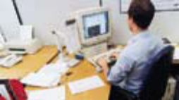   | ✓   |  | Create more room by moving printers, reference materials etc. elsewhere.  If necessary, consider providing new power and telecom sockets, so equipment can be moved.  There should be some scope for flexible rearrangement.

Can the user comfortably reach all the equipment and papers they need to use? |  |  | Rearrange equipment, papers etc. to bring frequently used things within easy reach.  A document holder may be needed, positioned to minimise uncomfortable head and eye movements.

Are surfaces free from glare and reflection? |  |  | Consider mats or blotters to reduce reflections and glare.

Is the chair suitable, comfortable, and stable?  Does the chair have adjustable?  - Seat back height and tilt.  - Swivel?  Castors movement? |  |  | The chair may need repairing or replacing if the user is uncomfortable, or cannot use the adjustment mechanisms.

Is the chair adjusted for your comfort?  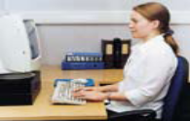✓  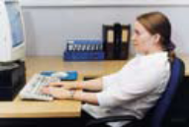  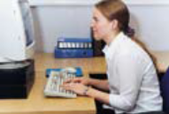 |  |  | The user should be able to carry out their work sitting comfortably.  Consider training the user in how to adopt suitable postures while working.  The arms of chairs can stop the user getting close enough to use the equipment comfortably.  Move any obstructions from under the desk.

Areas to be investigated when making an assessment | Tick answer  YES NO |  | Ways of reducing the risk |  | Action to take

5. Furniture (cont)

Is the small of the back supported by the chair’s backrest? |  |  | The user should have a straight back, supported by the chair, with relaxed shoulders.

Are forearms horizontal and eyes at roughly the same height as the top of the VDU? |  |  | Adjust the chair height to get the user’s arms in the right position, then adjust the VDU height, if necessary.

Are feet flat on the floor, without too much pressure from the seat on the back of the legs? |  |  | If not, a foot rest may be needed.

Areas to be investigated when making an assessment | Tick answer  YES NO |  | Ways of reducing the risk |  | Action to take

6. Environment

Is there enough room to change position and vary movement? |  |  | Space is needed to move, stretch, and fidget.  Consider reorganising the office layout and check for obstructions.  Cables should be tidy and not a trip or snag hazard.

Is the lighting suitable, e.g. not too bright, or too dim to work comfortably?  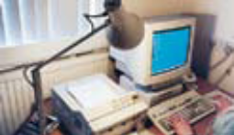 |  |  | Users should be able to control light levels, e.g. by adjusting window blinds or light switches.  Consider shading or repositioning light sources or providing local lighting, e.g. desk lamps (but make sure lights don’t cause glare by reflecting off walls or other surfaces).

Does the air feel comfortable? |  |  | VDUs and other equipment may dry the air.  Circulate fresh air if possible. Plants may help.  Consider a humidifier if discomfort is severe.

Are levels of heat comfortable? |  |  | Can heating be better controlled? More ventilation or air-conditioning may be required if there is a lot of electronic equipment in the room. Or, can users be moved away from the heat source?

Are levels of noise comfortable? |  |  | Consider moving sources of noise, e.g. printers, away from the user. If not, consider soundproofing.

7. Final questions to users

Tick answer
YES NO
- Has the checklist covered all the problems associated with working with DSE?
- Do you experience any discomfort or other symptoms which you attribute to working with DSE? (if yes, detail below)
- Have you been advised of your entitlement to eye and eyesight testing?
- Do you take regular breaks working away from DSE?
Write details of any problems here:

